**BrightLearn Data Analytics : Kabe M**

**Case Study : Sales**

**1.**

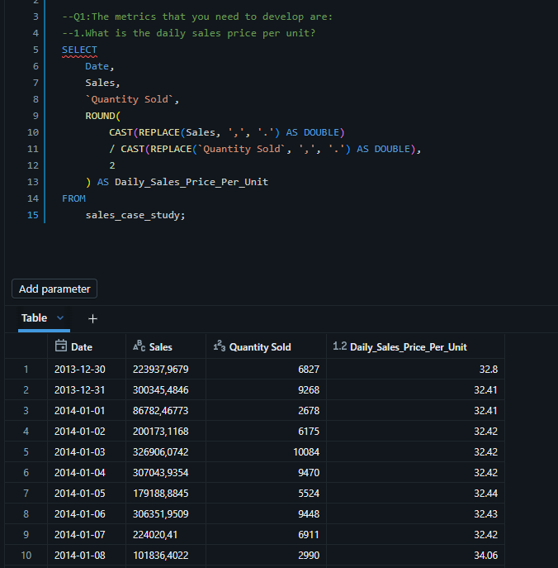

2.

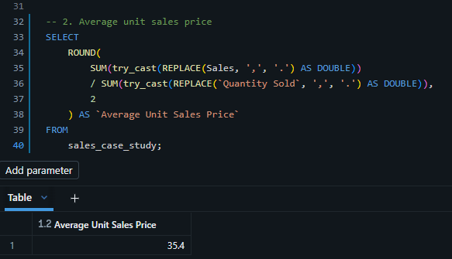

3.

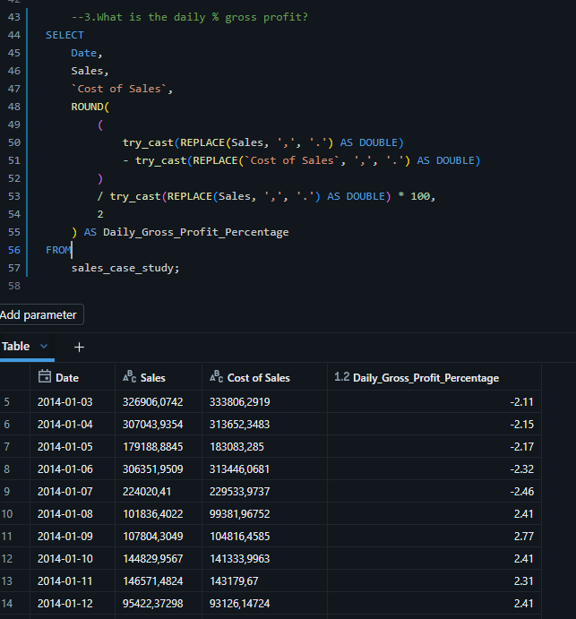

4.

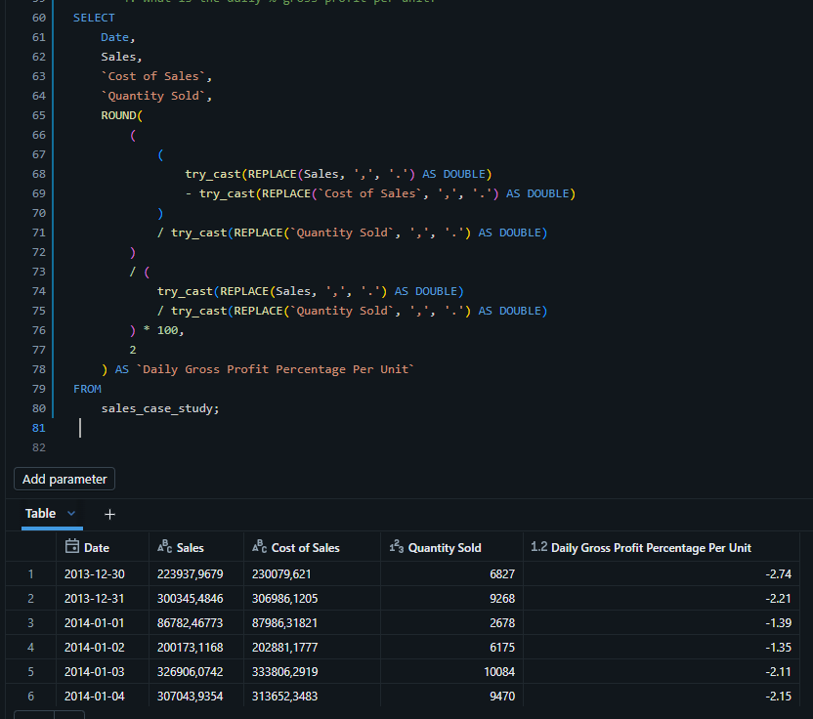

5.

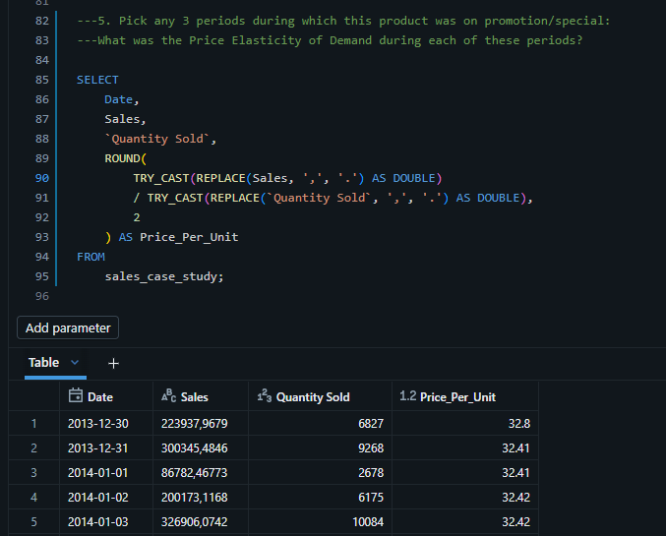

6.

   ---5.2.Pick any 3 periods during which this product was on promotion/special:

    ---In your opinion, does this product perform better or worse when sold at a promotional price?

---Using PED to Analyze Performance

---Price Elasticity of Demand (PED) tells us how sensitive sales are to price changes.

---PED Value  Interpretation

---> 1 (elastic)  Quantity responds strongly to price → lower price increases total revenue

---<- 1 (inelastic) Quantity responds weakly → lower price may reduce total revenue

---= 1 (unit elastic) Total revenue stays roughly the same

---| Period    | PED | Total Revenue Change | Performance     |

--| --------- | --- | -------------------- | --------------- |

--| Jan 10-15 | 1.5 | ↑ 20%                | Performs better |

--| Feb 05-10 | 0.8 | ↓ 5%                 | Performs worse  |